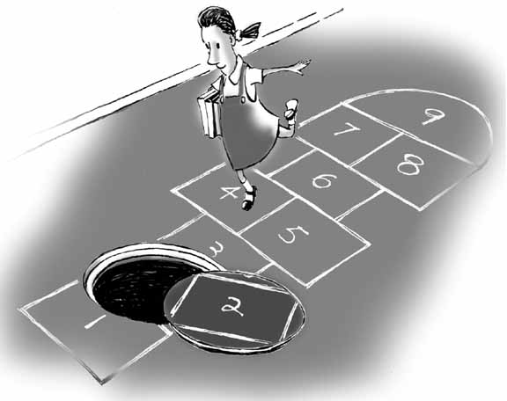
Hopscotch

Final Deadline: 2/6 before class via e-mail to Ira

The goal of this assignment is to create an improved version of Hopscotch. Document your process as you go. Your work will be judged on your documentation and how enjoyable a game you manage to create for the intended audience.

Restrictions:
- No drinking games.
- Must involve some physical activity (no pure board games).

Part I
- List problems with hopscotch that your improved design might try to solve.
- Brainstorm (in writing) at least twenty ideas about your game. You might also find it useful to brainstorm in categories: Game Rules, Target Audience, Materials/Technology Used, Story, all five senses, etc.

Part II
Take at least one of your ideas from Part I, and:
- Write the complete game rules.
- Try playing it and record at least the following details (be specific!):
  - Who played
  - How long did the game take
  - What was the final score of each player
  - Anything else significant
- Analyze (in writing) what is good and bad about it.
- Update the rules based upon your analysis, and try playing it again.
  - Record the same details as Part (b) above.
- Analyze (in writing) the “improved” version.
- Include at least one photograph (or video) of someone playing your final game.

Original assignment designed by Professor Jesse Schell, used with permission. Updated by Professor Ira Fay.

